1. Create a program that takes a student's score as input and assigns a grade based on predefined criteria using logical operators (e.g., A, B, C, D, F).

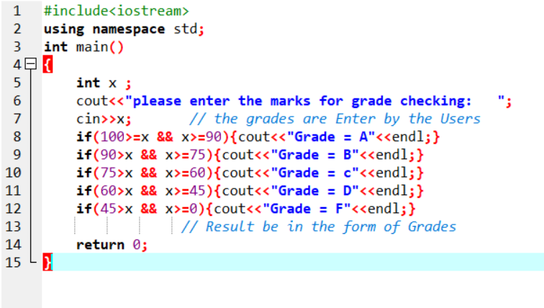

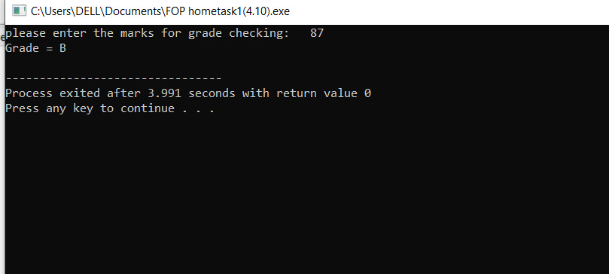

2. Write a program that takes an integer as input and determines if it is both even and divisible by 5.

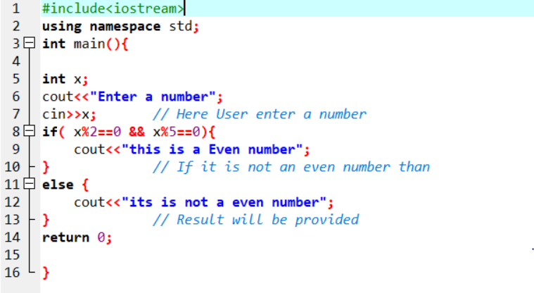

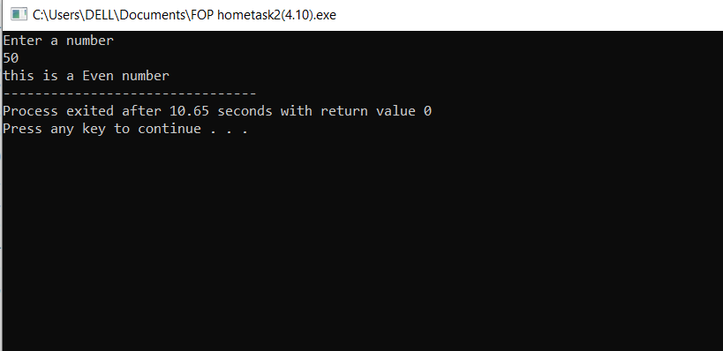

3. Create a C++ program that checks if a user-provided year is a leap year.

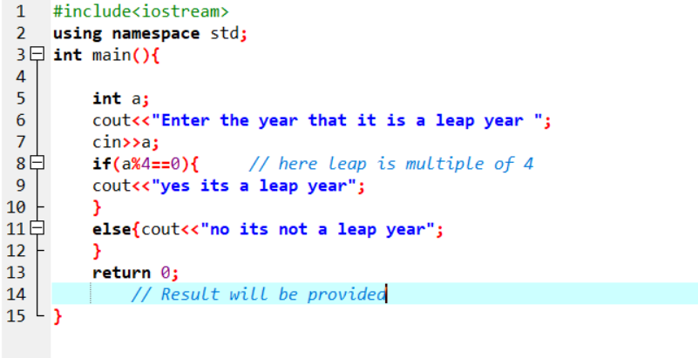

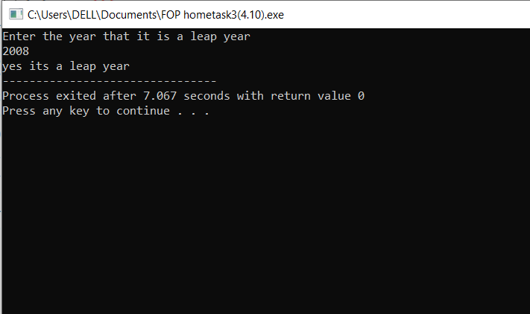

4. Create a C++ program that determines if a student is eligible for a scholarship based on their GPA (must have GPA >= 3.5) and attendance (must have attended at least 80% of classes).

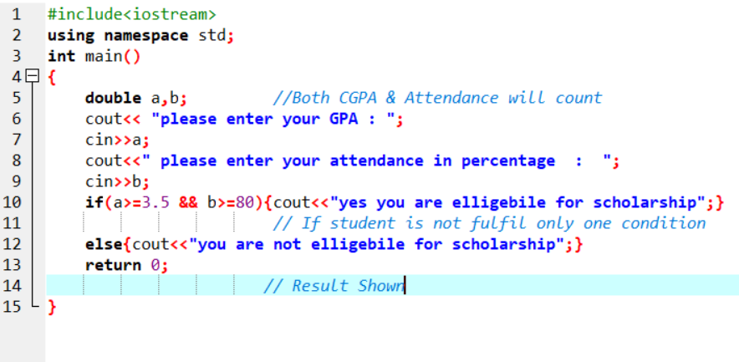

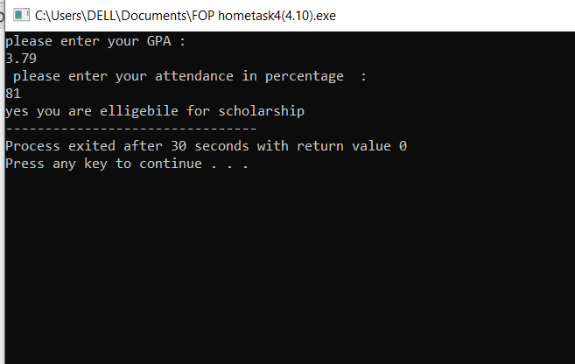

5. Write a program that checks if a given character is a vowel (a, e, i, o, u) or a consonant using logical operators.

